 | Functional/Technical Change Specification  Pallet Tagging/Process System &  Stock Transport Orders @ MFA

Author(s):

Linden Glen | (MFANZ Site Applications Analyst)



TABLE OF CONTENTS
1. DOCUMENT MODIFICATION HISTORY 1
2. Introduction 2
2.1. Document Scope 2
2.2. Application Overview 2
2.3. Change Overview 2
3. PTS / STO Schema Overview 3
4. Citect > Oracle Interface 4
4.1. Interface: Production Interface 4
4.2. Process Order Goods Receipts 5
4.3. Pallet Good Receipts 5
4.3.1. Reworks (RWKCANCEL & RWKCREATE) 6
4.3.2. Tables : [PT.PTS_PLT][PT.PTS_TRANS] 6
4.3.3. History 6
4.3.4. Backflush 6
5. Oracle > Atlas Interface 7
5.1. File Specification 7
5.1.1. Reverse Goods Receipt Posting (Z_PI2) 8
6. PTS Views (Oracle > Citect) 9
6.1. View: PTS_HOLD_CODES 9
6.2. View: PTS_PLT_MISSING_VIEW 9
6.3. View: PTS_PLT_ONSITE_VIEW 9
6.4. View: PTS_STO_VIEW 10
7. Stock Transport Order (STO) 11
7.1. Tolas > Oracle 11
7.1.1. STO File Specification 11
7.1.2. Batch Interface Tables [PT.BATCH_CNTL][PT.BATCH_DATA][PT.BATCH_ERR] 12
7.1.3. Stock Transport Order (STO) Tables [PT.STO_INTFC][PT.STO][PT.STO_DTL] 12
7.1.4. ShipTo Table [PT.PSH_SHIPTO] 12
7.1.5. Acknowledgement Process (Freshness Interface) 13
7.2. Oracle > Tolas 13
7.2.1. Quality File Specification 13
7.3. Transaction Types 13
7.3.1. STO Confirm & Cancel 13
7.3.2. Disposition 13
7.3.3. Receipt 14
7.4. AIX Processing (Tolas > Oracle & Oracle > Tolas) 14
7.4.1. Path Structure 14
7.4.2. Script Files (Korn Shell) 14
7.4.3. Data Files 14
7.4.4. Root Cron (Schedule) 15
8. Historical Data Conversion Plan 15
9. Environment 15
9.1. Development 15
9.2. Test 15
9.3. Production 16
10. Testing 16
10.1. Development Testing 16
10.2. Key User Testing 16
10.3. BIT 16
11. Support Documentation 16
11.1. Locating Batch & Citect Errors 16
11.2. How to Reprocess or Delete Errors 16
11.3. How to Re-Queue a File 17
12. Appendix 17
12.1. Master Foods Pallet Tagging and Stock Transfer Authority (v1.1) 17
12.2. Masterfoods Quality Hold / Release System Functional Specification 17

DOCUMENT MODIFICATION HISTORY

Version | Date | Modified By | Comment/Notes
1.0 | 1st March, 2004 | Linden Glen | Original
2.0 | 6th April, 2004 | Linden Glen | Re-structured document and included details on handling of process order GR’s via new Oracle Procedure Interface. Included details of development environment.
3.0 | 22nd April, 2004 | Linden Glen | Added Relevant documentation from original Pallet Tagging Specification (including support details)
3.1 | 23rd April, 2004 | Linden Glen | Included colouring to PRODUCTION_INTFC() specification table to allow for identification of mandatory fields.
4.0 | 27th April, 2004 | Linden Glen | Added specification of views used in the PTS
5.0 | 2nd May, 2004 | Linden Glen | Added specification of Pallet SHIPTO file received from Tolas > Oracle

Introduction

Document Scope
This document describes the functionality and operation of the Pallet Tagging System (PTS) after changes made as a result of the Atlas implementation. It also covers Stock Transport Orders (STO) that integrates with the PTS for Pallet Trace reporting and movement of stock to Tolas (previously known as Stock Transfer Authority or STA). This specification is written based on the PTS/STO system at MFA, where the first implementation of Atlas will be template version 3.0, which will not support pallet level information.

Also covered is the addition of new functionality, which allows for the automated recording and tracking of process good receipts that are not palletised. For example, mixes, packaging, etc. Both this function and that of pallet tagging will be referred to as Goods Receipt within this document, unless otherwise written.

The Factory Control System (Citect) will also require modifications, however, these details should be covered in a separate specification, to be written by the FCS team at MFA.

Application Overview
The PTS uniquely tracks each pallet from the moment it is created. This allows for controls to be placed on pallet reworks, disposition changes, cancels, etc. The PTS interfaces with the factory control system (Citect) via an Oracle stored procedure. Citect makes a call to this procedure when a pallet or process goods receipt (GR) is created, which contains details specific to the pallet or process. Once a pallet has been generated, it can then have transactions performed on it – such as HOLD, RWKCANCEL, CANCEL, etc. A process transaction can only be cancelled.

Upon creation or cancellation of a pallet or process GR within Oracle, a message is submitted to Atlas detailing the transaction. Within Atlas, a Citect transaction type of ‘CREATE’ or ‘PRC_CREATE’ is known as a Goods Receipt (ZPI_1), and ‘CANCEL’ or ‘PRC_CANCEL’ as Reverse Goods Receipt (ZPI_2). These messages will be generated and submitted to Atlas for processing in real-time.

The STO portion of this system tracks each pallets location, and if available, where it was shipped. A report (Product Tracing) sits over this data, allowing QA to easily identify where products are should a recall be necessary. The STO functionality also allows the PTS system to identify when a pallet has been checked into Tolas (Warehouse Management System), hence stopping disposition changes to the pallet external to Tolas.

Change Overview
Several major changes will be required to the PTS/STO system to allow it to continue working post Atlas implementation. These changes are:

- Backflush functionality to be removed (done within Atlas) on Goods Receipt or Reverse Goods Receipt
- Receipt to MANMAN functionality to be removed (MANMAN decommissioned)
- Modified interface with Citect to handle new data requirements on pallet creation/cancellation
- Automated generation and send of Goods Receipt file to Atlas after pallet creation
- Automated generation and send of Reversal of Goods Receipt file to Atlas after pallet cancellation
- Modification of STO load scripts to allow for changed naming convention & data content
- Modification of STO tables to handle additional and modified data (e.g. batch code, CNN, etc)
- Resizing/Modification/Addition of several fields to accommodate changed data, e.g. ITEM_CODE NUMBER(6) is now MATERIAL_CODE VARCHAR2(8).
- STA codes will now be known as STO Consignment Note Numbers (or CNN’s). e.g. sta_code is now sto_cnn_code.
- To allow for a common interface for both goods receipts at pallet tagging and end of a process order, an Oracle Stored Procedure will now be used.. Citect will make a call to this procedure for already existing transactions, and two new ones created for end of process receipting (PRC_CREATE & PRC_CANCEL). Processes (not palletised) will be stored in a separate table (pt.process_intfc).

Several changes will also need to be made to Citect to allow it to both store and insert the new and modified data into Oracle. The team responsible for Citect’s operation (Inbound) should generate a specification outlining these changes.

PTS / STO Schema Overview
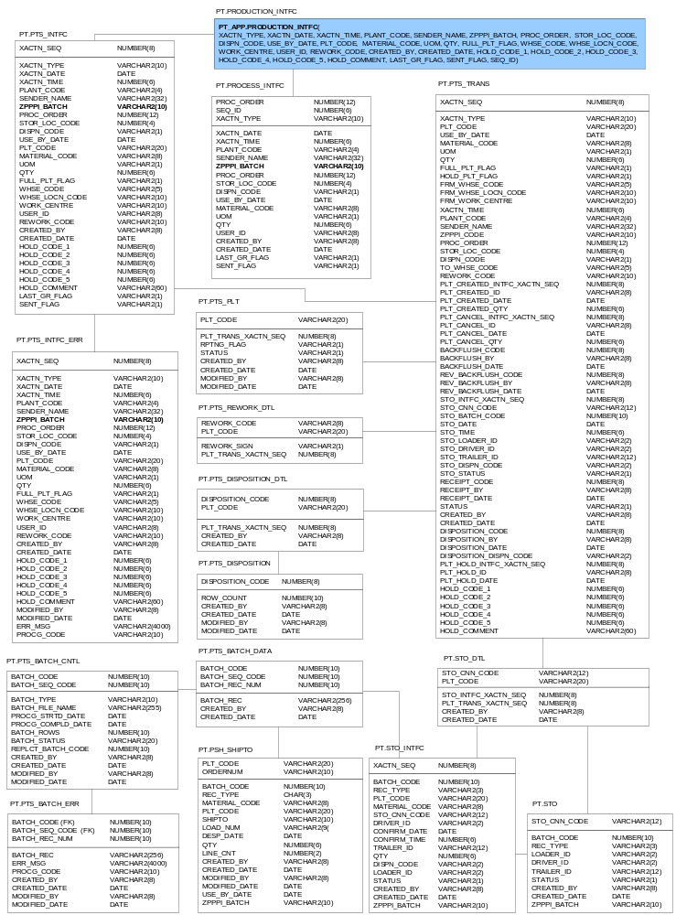

Citect > Oracle Interface
The Oracle procedure (pt_app.production_intfc()) provides a common interface for Citect to create and control transactions. The procedure, called via ODBC, accepts a number of variables, which are used to track transactions and generate and send message to Atlas where necessary.

There are two core functions that the interface handles. These are the input of transactions on pallets, and the input of transactions of process good receipts (not palletised).

Production Interface Specification
Below is the specification of the interface stored procedure.

pt_app.production_intfc(
iv2#XACTN_TYPE IN VARCHAR2,
id#XACTN_DATE IN DATE,
in#XACTN_TIME IN NUMBER,
iv2#PLANT_CODE IN VARCHAR2,
iv2#SENDER_NAME IN VARCHAR2,
iv2#ZPPPI_BATCH IN VARCHAR2,
in#PROC_ORDER IN NUMBER,
in#STOR_LOC_CODE IN NUMBER,
iv2#DISPN_CODE IN VARCHAR2,
id#USE_BY_DATE IN DATE,
iv2#MATERIAL_CODE IN VARCHAR2,
iv2#UOM IN VARCHAR2,
iv2#PLT_CODE IN VARCHAR2,
in#QTY IN NUMBER,
iv2#FULL_PLT_FLAG IN VARCHAR2,
iv2#WHSE_CODE IN VARCHAR2,
iv2#WHSE_LOCN_CODE IN VARCHAR2,
iv2#WORK_CENTRE IN VARCHAR2,
iv2#USER_ID IN VARCHAR2,
iv2#REWORK_CODE IN VARCHAR2,
in#HOLD_CODE_1 IN NUMBER,
in#HOLD_CODE_2 IN NUMBER,
in#HOLD_CODE_3 IN NUMBER,
in#HOLD_CODE_4 IN NUMBER,
in#HOLD_CODE_5 IN NUMBER,
iv2#HOLD_COMMENT IN VARCHAR2,
iv2#LAST_GR_FLAG IN VARCHAR2,
in#SEQ_ID IN NUMBER);

Process Order Goods Receipts
When making a process GR call to the interface, the following two transaction types are valid:

Transaction Type | Description
PRC_CREATE | Production Creation of a Process GR that is not palletised (e.g. mixes, packing, etc)
PRC_CANCEL | Production Cancel of a Process GR (not palletised)

Note: A process cannot be cancelled without have been created.

All process transactions (once validated) are written to the (pt.process_intfc) table. No further processing is undertaken on these records once written to the table, except when a message for Atlas is generated which happens automatically.

The following fields are available for use when performing either of these transactions (all others will be ignored):

Field Name | Type (Size) | Example
XACTN_TYPE | VARCHAR2(10) | ‘CREATE’
XACTN_DATE | DATE (YYYYMMDD) | 20040302
XACTN_TIME | TIME (HHMMSS) | 143321
PLANT_CODE | VARCHAR2(4) | AU10
SENDER_NAME | VARCHAR2(32) | ‘PTS-SQO BULK’
ZPPPI_BATCH | VARCHAR2(10) | 433B1WYO01
PROC_ORDER | NUMBER(12) | 000001010848
USE_BY_DATE | DATE
STOR_LOC_CODE | NUMBER(4) | 0001
DISPN_CODE | VARCHAR2(1) | ‘X’
MATERIAL_CODE | VARCHAR2(8) | 00123456
UOM | VARCHAR2(1)
QTY | NUMBER(6) | 1200
USER_ID | VARCHAR2(8) | 2100171
LAST_GR_FLAG | VARCHAR2(1) | X
SEQ_ID | NUMBER(6) | 3

Pallet Good Receipts
When making a pallet GR call to the interface, the following transaction types are valid:

Transaction Type | Description
CREATE | Production Pallet Creation (POST GOODS RECEIPT)
CANCEL | Production Pallet Cancel (REVERSE POST GOODS RECEIPT)
RWKCANCEL | Rework is identified and raised by QA against individual pallet tags. QA assigns a rework code to each pallet to be reworked. A RWKCANCEL is then performed on that pallet
RWKCREATE | Once a pallet has been RWKCANCEL’d, it can then be rework created
HOLD | Place pallet on hold
HOLDCANCEL | Remove pallet from hold

All fields are available for this transaction type, except for SEQ_ID which is specific to Process GR’s. Once a record has passed validation, it is inserted into the table (pt.pts_intfc) where further processing occurs based on table triggers.

When a pallet is physically created, placed or taken off hold, rework created or cancelled, Citect will make a call to the procedure (pt_app.production_intfc) via ODBC. The call will include information regarding the pallet transacted. Both validation within the procedure and triggers on the tables where the data is inserted to will ensure transactions are valid before being cleared to the Pallet Interface Table (pt.pts_intfc). The processing that this procedure initiates (when transacting a pallet) is:
- Disallows UPDATES and DELETES
- Ensures transaction type is valid (CREATE, CANCEL, RWKCREATE, RWKCANCEL, HOLD, HOLDCANCEL)
- That reworks have rework codes
- That at least 1 hold code is provided for HOLD transactions
- That a user ID has been provided for all non-CREATE transactions
- That a pallet exists before it is cancelled, or placed on hold
- If record of type ‘CREATE’ or ‘CANCEL’ a message is generated and submitted to Atlas.

Reworks (RWKCANCEL & RWKCREATE)
Atlas currently has no interfaces for rework transactions, therefore, this information will need to be maintained in both the PTS and Atlas. Rework transactions from Citect to Oracle will continue to operate with the same functionality, however, an additional step will be required by the associate performing the rework as they will need to enter the rework information into Atlas as well.

This scenario is somewhat undesirable as it means similar data is being maintained in two separate locations. Having said this, it is the only method of tracking reworks at both a case level (Atlas) and a pallet level (PTS) whilst MFA has Atlas version 3.0 (which does not support pallet level information).

Tables : [PT.PTS_PLT][PT.PTS_TRANS]
The Pallet Table’s function is to provide a direct path to a pallet’s current (most recent) transaction, within the Pallet Transaction Table. The Pallet Transaction Table is the heart of the Pallet Tagging System, and contains a record for each transaction performed on a pallet.

Each record within this table is accumulative – that is, it includes all the information from the pallet’s previous transaction, excepting where the pallet’s current transaction would preclude this.

History
The HISTORY transaction type was created to allow the loading of pallet data from the original Access DB to the PTS when it was first implemented. Whilst this transaction type is no longer used it will remain accessible as the need to load HISTORICAL pallet data may arise in the future. Note: this transaction is internal to the PTS, and not available to call via the production_intfc() procedure.

Backflush
Whilst the transaction type of ‘BACKFLUSH’ and ‘-BACKFLUSH’ will be disallowed, the backflush fields within (pt.pts_trans) will remain as they will still be required to provide historical data about transactions performed on pallets.

Oracle > Atlas Interface
The diagram below simplifies the idea of the two functions that the oracle interface performs:

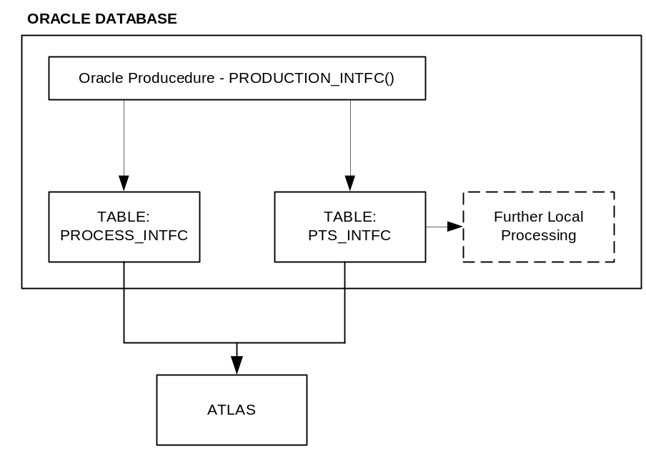

As the diagram suggests, both of the interface tables store the data which makes up the control messages that are sent to Atlas. Each table has a column named SENT_FLAG, which is populated with a ‘Y’ when the message for that record has been successfully posted to Atlas. When an interface from Citect to Oracle occurs, the procedure attempts to post the message instantly to Atlas. Should this fail, a background job frequently checks these two tables for any records that have not been posted, and attempts to resend.

It should also be noted that only the following four transaction types will trigger a message to Atlas: CREATE, CANCEL, PRC_CREATE and PRC_CANCEL.

The interface from Oracle to Atlas is made possible by using the pass-through interface package (lics_outbound_loader) available on the Interface Control System (ICS), this message can be generated and dispatched from within the procedure create_idoc().

The usage of this interface (as used in CREATE_IDOC()) is defined as follows:

lics_outbound_loader.create_interface ( interface_code varchar2 ) - called once to create interface
lics_outbound_loader.append_data ( message_line varchar2 ) - called per message line
lics_outbound_loader.add_exception ( exception_string varchar2 ) - called per exception message
lics_outbound_loader.finalise_interface() - must be called at interface end
lics_outbound_loader.is_created() - returns TRUE if interface exists

File Specification
This is the format the Goods Receipt message should be in when it is passed through the ICS interface. The call to this package will need to operate over a DB Link to the ICS server.

Record | Start | End | Length | Oracle  Type (Size) | Example | Format/Comments
HDR Header Code | 1 | 3 | 3 | VARCHAR2 (3) | ‘HDR’ | Fixed
Process Message ID (TMP) | 4 | 21 | 18 | NUMBER (18) | 000000000000000001 | Fixed
Plant Code | 22 | 26 | 4 | VARCHAR2 (4) | ‘AU10’
Process Message Category | 27 | 35 | 8 | VARCHAR2 (8) | Z_PI1 or Z_PI2 | Z_PI1 = Goods Receipt  Z_PI2 = Reverse GR
Sender Name | 36 | 68 | 32 | VARCHAR2 (32) | ‘PTS GLASSLINE’ or ‘Wyong PTS’ | Identify location of tagging
Test Flag | 69 | 69 | 1 | VARCHAR2 (1) | ‘X’ or NULL | X = Test Message (i.e will not process in Atlas)  NULL = Production Message
DETAILS (REPEATED PER VARIABLE)
DET Detail Code | 1 | 3 | 3 | VARCHAR2 (3) | ‘DET’ | Fixed
Process Message ID (TMP) | 4 | 21 | 18 | NUMBER (18) | 000000000000000001 | Fixed
Characteristic Name (NAME_CHAR) | 22 | 52 | 30 | VARCHAR2 (30) | ‘PPPI_EVENT_DATE’ | Will change for each detail record to identify the value
Characteristic Value (CHAR_VALUE) | 53 | 83 | 30 | VARCHAR2 (30) | ‘20040301’ | Will change format and type depending on NAME_CHAR
Characteristic Data Type (DATA_TYPE) | 84 | 88 | 4 | VARCHAR2 (4) | ‘CHAR’ | Specifies data type of field – will change depending on NAME_CHAR

For Example:

HDR000000000000000001AU10Z_PI1 Wyong Pallet Tagging System
DET000000000000000001PPPI_PROCESS_ORDER 000001010848 CHAR
DET000000000000000001PPPI_EVENT_DATE 20040301 DATE
DET000000000000000001PPPI_EVENT_TIME 034448 TIME
DET000000000000000001PPPI_MATERIAL AF007818 CHAR
DET000000000000000001PPPI_MATERIAL_PRODUCED 25 NUM
DET000000000000000001PPPI_UNIT_OF_MEASURE CS CHAR
DET000000000000000001PPPI_STORAGE_LOCATION 0001 CHAR
DET000000000000000001PPPI_STOCK_TYPE X CHAR

Reverse Goods Receipt Posting (Z_PI2)
When Citect performs a CANCEL or PRC_CANCEL transaction, an instantaneous Reverse of Goods Receipt message must be sent to Atlas. This interface will operate in exactly the same manner as the Goods Receipt of Production, however, the message category will be set to “Z_PI2”.

PTS Views (Oracle > Citect)

View: PTS_HOLD_CODES
Provides a view of all hold reason types that are active (i.e. where status = ‘A’)

Field Name | Type (Size)
HOLD_CODE | NUMBER(8)
SHORT_DESC | VARCHAR2(10)
DESCRIPTION | VARCHAR2(60)

View: PTS_PLT_MISSING_VIEW
Provides a view of all pallets which have not been received by the warehouse. This is based on not having received a PSH or STO interface file from Tolas.

Field Name | Type (Size)
PLT_CODE | VARCHAR2(20)

View: PTS_PLT_ONSITE_VIEW
Provides a view of all pallets which are currently still onsite (i.e. have not yet been confirmed into Tolas/WH).

Field Name | Type (Size)
XACTN_SEQ | NUMBER(8)
XACTN_TYPE | VARCHAR2(10)
PLT_CODE | VARCHAR2(20)
USE_BY_DATE | DATE
MATERIAL_CODE | VARCHAR2(8)
UOM | VARCHAR2(1)
QTY | NUMBER(6)
FULL_PLT_FLAG | VARCHAR2(1)
HOLD_PLT_FLAG | VARCHAR2(1)
FRM_WHSE_CODE | VARCHAR2(5)
FRM_WHSE_LOCN_CODE | VARCHAR2(10)
FRM_WORK_CENTRE | VARCHAR2(10)
XACTN_TIME | NUMBER(6)
PLANT_CODE | VARCHAR2(4)
SENDER_NAME | VARCHAR2(32)
ZPPPI_BATCH | VARCHAR2(10)
PROC_ORDER | NUMBER(12)
STOR_LOC_CODE | NUMBER(4)
DISPN_CODE | VARCHAR2(1)
TO_WHSE_CODE | VARCHAR2(5)
REWORK_CODE | VARCHAR2(10)
PLT_CREATED_INTFC_XACTN_SEQ | NUMBER(8)
PLT_CREATED_ID | VARCHAR2(8)
PLT_CREATED_DATE | DATE
PLT_CREATED_QTY | NUMBER(6)
PLT_CANCEL_INTFC_XACTN_SEQ | NUMBER(8)
PLT_CANCEL_ID | VARCHAR2(8)
PLT_CANCEL_DATE | DATE
PLT_CANCEL_QTY | NUMBER(6)
BACKFLUSH_CODE | NUMBER(8)
BACKFLUSH_BY | VARCHAR2(8)
BACKFLUSH_DATE | DATE
REV_BACKFLUSH_CODE | NUMBER(8)
REV_BACKFLUSH_BY | VARCHAR2(8)
REV_BACKFLUSH_DATE | DATE
STO_INTFC_XACTN_SEQ | NUMBER(8)
STO_CNN_CODE | VARCHAR2(12)
STO_BATCH_CODE | NUMBER(10)
STO_DATE | DATE
STO_TIME | NUMBER(6)
STO_LOADER_ID | VARCHAR2(2)
STO_DRIVER_ID | VARCHAR2(2)
STO_TRAILER_ID | VARCHAR2(12)
STO_DISPN_CODE | VARCHAR2(2)
STO_STATUS | VARCHAR2(1)
RECEIPT_CODE | NUMBER(8)
RECEIPT_BY | VARCHAR2(8)
RECEIPT_DATE | DATE
STATUS | VARCHAR2(1)
CREATED_BY | VARCHAR2(8)
CREATED_DATE | DATE
DISPOSITION_CODE | NUMBER(8)
DISPOSITION_BY | VARCHAR2(8)
DISPOSITION_DATE | DATE
DISPOSITION_DISPN_CODE | VARCHAR2(2)
PLT_HOLD_INTFC_XACTN_SEQ | NUMBER(8)
PLT_HOLD_ID | VARCHAR2(8)
PLT_HOLD_DATE | DATE
HOLD_CODE_1 | NUMBER(6)
HOLD_CODE_2 | NUMBER(6)
HOLD_CODE_3 | NUMBER(6)
HOLD_CODE_4 | NUMBER(6)
HOLD_CODE_5 | NUMBER(6)
HOLD_COMMENT | VARCHAR2(60)

View: PTS_STO_VIEW
Provides a view of all pallets which have been received and confirmed by the warehouse (Tolas).

Field Name | Type (Size)
PLT_CODE | VARCHAR2(20)
BATCH_CODE | NUMBER(10)
STO_CNN_CODE | VARCHAR2(12)
CREATED_DATE | DATE

Stock Transport Order (STO) & Pallet Shipments
The STO process is how the movement of stock from the factory to the warehouse, and then to a customer is tracked. When finished goods are produced, they are loaded onto pallets, which are in turn loaded onto a truck. A Mars associate (using a Tolas RF scanner) scans each pallet on the truck, as well as the trailer ID. Following this, the driver scans every pallet on the truck. If both scans match, then a load is created within Tolas. This means that the stock has now been checked into Tolas as “intransit”. At this stage, the disposition of the goods can no longer be changed within the PTS as this is controlled within Tolas.

Once Tolas has the load confirmed, it produces an STO file which it places on a queue on the MFA Datawarehouse (WYU001 - MFA.TOLAS.PRODREC.QUEUE). This file contains details of the load, e.g. pallets, product, trailer and driver ID, etc. A summary of the physical and data flow is below:

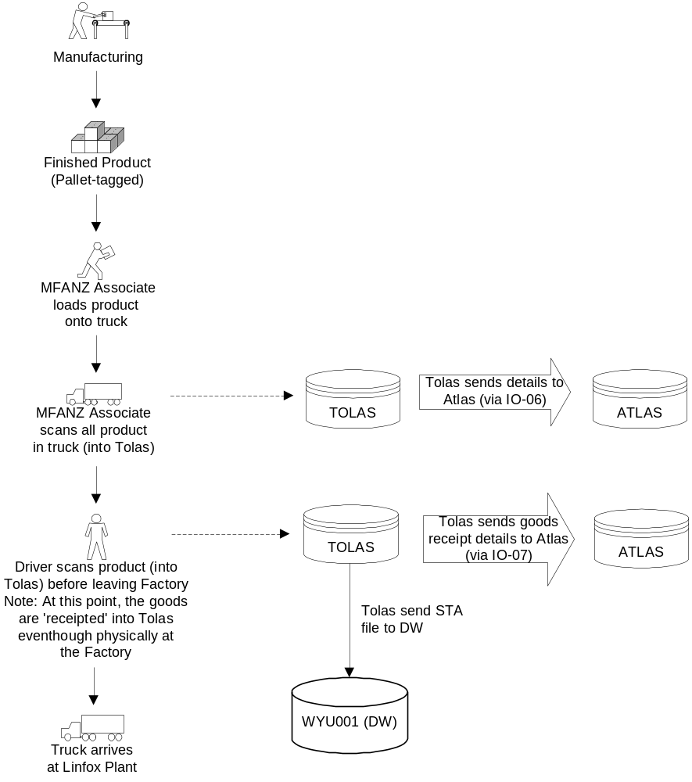

Physical flow from Palletiser to Warehouse + Data flow from Tolas to Atlas and DW

Tolas > Oracle

STO File Specification
The STA file that Tolas produces and sends to MFA once a load is confirmed is specified as follows:

“R” Type File (STO Receipt) – Tolas > DW – Filename RSTA99999999.INT

Field Name | Description | Format | Comments
T_RECTYP | Record type | X(3) | Constant “REC”
T_PLATE | Pallet Number | X(20) | Increased from X(8)
T_PRDID | Product code | X(8) | Increased from X(6)
T_STANUM | CNN Number | X(12) | Increased from X(7)
T_USERID | Confirm User ID | X(2)
D_CNFDTE | Confirm Date | CCYYMMDD
T_CNFTIM | Confirm Time | HH:MM:SS
T_TRAIL | Trailer ID | X(12)
T_STAQTY | Quantity | 9(6)
T_DSPCOD | Disposition Code | X(2)
T_CREID | Create User ID | X(2)
T_STATUS | Status | X(1) | ‘C’ Confirmed or ‘X’ Cancelled
T_BATLOT | Batch | X(10) | New field

Once this file is received by WYU001 via a queue, the script (WYU001:/mfadw/prod/PALLET/sta.ksh) runs, removing the file and loading it into Oracle.

Pallet Shipments File Specification
The PSH file that Tolas generates and sends to MFA once a pallet is shipped to a customer is specified as follows:

“S” Type File (Pallet Shipments) – Tolas > DW – Filename SPSH99999999.INT

Field Name | Description | Format | Comments
T_RECTYP | Record type | X(3) | Constant “PSH”
T_PRDID | Product code | X(8) | Increased from X(6)
T_PLATE | Pallet ID | X(20) | Increased from X(8)
T_SHPCUS | Shipto customer number | X(10)
T_LODNO | Load number | X(9)
T_SHPNO | Order number | X(10) | Increased from X(9)
D_DSPDTE | Despatch date | X(8)
T_SHPQTY | Ship Quantity | 9(6)
D_USEDTE | Use by date | X(8)
T_BATLOT | Batch code | X(10) | New field

Batch Interface Tables [PT.PTS_BATCH_CNTL][PT. PTS_BATCH_DATA]
[PT. PTS_BATCH_ERR]
The Batch Tables perform an intermediary table task – between the Oracle External Data and Validated Oracle Internal Tables. Put simply, the Control table fulfils the control function. It uniquely tracks each batch, their type, progress and status.
Data and Error tables contain the contents of each batch – data for processing and error for correction and reprocessing. These tables currently control the entry and processing of the ‘R’ (Stock Transfer Authority) and ‘S’ (Ship To) files out of Tolas.

Stock Transport Order (STO) Tables [PT. PTS_STO_INTFC][PT. PTS_STO][PT. PTS_STO_DTL]
The STO Interface Table contains a copy of the ‘S’ file batches that have been successfully posted. While the STO and STO Detail Tables record information to facilitate the validation of STO batch postings with links back to the original Pallet and STO transactions.

Tolas generates a Stock Transport Order file for each Confirmed or Cancelled Stock Transport Order. These files are placed on the MFA.TOLAS.PRODREC.QUEUE.
The Stock Transport Order Process is kicked off periodically (via Root Cron - sta.ksh). It’s purpose is to load the R###### files from the MFA.TOLAS.PRODREC.QUEUE into the Pallet Tagging Database – through the use of the Batch process.

ShipTo Table [PT.PSH_SHIPTO]
The Ship To Table is populated by the ‘S’ file from Tolas, and records a cross reference between pallets and their ship to destinations.

NOTE: This table is loaded as is, with no validations beyond mandatory data type validations. Where a match on pallet and deliver to is encountered, the new record replaces the old record.

Tolas generates a Pallet Ship To file periodically containing the Pallet Ship To combinations. These files are placed on the MFA.TOLAS.DW.FT.QUEUE. The Pallet Ship To Process is kicked off periodically (via a Root Cron - psh.ksh). It’s purpose is to load the S###### files from the MFA.TOLAS.DW.FT.QUEUE into the Pallet Tagging Database – through the use of the Batch process.

Acknowledgement Process (Freshness Interface)
Acknowledgement files are sent from Tolas to MFA whenever a file is received and processed by Tolas. These acknowledgements are received on the MFA.TOLAS.ACK2DATAWH.QUEUE queue and are processed as part of the Freshness interface. The freshness interface handles ALL acknowledgements from Tolas.

Oracle > Tolas
Once the STA Receipt file has been received from Tolas and loaded into Oracle, a Quality file is sent back to Tolas from Oracle (WYU001). This file informs Tolas of the disposition of the stock it has. This file is necessary as all stock released into Tolas has the status of ‘HQ’ (Hold Quality), this then allows QA to release the product for sale (status ‘GD’) or keep it on hold (status ‘HD’). If a product is placed on hold, a valid hold reason code is also required.

Quality File Specification
“Q” Type File (Quality) – DW > Tolas – Filename (changed to) QUAL99999999.INT

Field Name | Description | Format | Comments
T_RECTYP | Record type | X(3) | Constant “QAL” or “999” (for trailer record)
T_STANUM | STA number | X(12) | Increased from X(7)
T_PLATE | Pallet ID | X(20) | Increased from X(8)
T_PRDID | Product code | X(8) | Increased from X(6)
T_DSPCOD | Disposition code | X(2)
T_DSPREF | Disposition reference | X(10)

The generation of this file is done via the AIX shell script (WYU001:/mfadw/prod/PALLET/sta.ksh). Within the code a function containing SQL exists which selects the relevant fields into a file and place it on the queue back to Tolas (MFA.TOLAS.DISPOSITION.QUEUE).

Transaction Types

Transaction Type | Description
STOCONFIRM | Stock Transfer Authority, Confirmation
STOCANCEL | Stock Transfer Authority, Cancellation
DSPOSITION | Pallet Disposition generation for Tolas Extract
RECEIPT | Pallet Receipt (Dispatch -> MANMAN)

STO Confirm & Cancel
When pallets are being scanned into Tolas there are two stages. The first being the scan by a Masterfoods associate, and the following one by the driver. Before the scan by the driver is confirmed, the load can be cancelled. This cancellation is recorded in the pts_trans table as a transaction on the pallet(s). This functionality was included in the STO system as it allows for reporting on how often and by whom loads were cancelled.

Once a pallet has been confirmed within Tolas an update file is sent to the data warehouse detailing the pallet and the STO CNN number. A pallet with an assigned CNN number in Oracle will be blocked from updating the disposition. It also allows visibility of what product is on site (as the ones with CNNs are off site).

Disposition
Once stock is confirmed as being received into Tolas, a disposition extract is generated and sent to Tolas, which sets the disposition of the stock. The stock can be either ‘HD’ Hold, or ‘GD’ Good, i.e. available for sale.

Receipt
Whilst the transaction type of ‘RECEIPT’ will be disallowed, the receipt fields within (pt.pts_trans) will remain as they will still be required to provide historical data about transactions performed on pallets.

AIX Processing (Tolas > Oracle & Oracle > Tolas)
The interface with Tolas and Oracle is made possible by shell scripts residing on WYU001 (AIX), that load files into Oracle, and generate and send files from Oracle data.

Path Structure
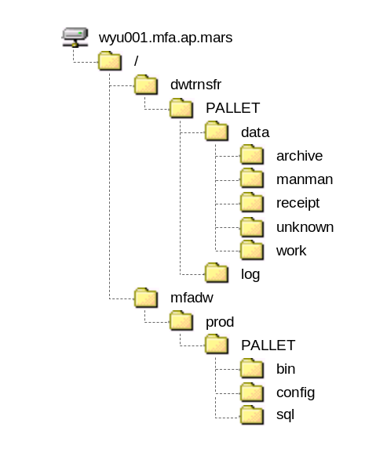

Script Files (Korn Shell)
Reside in: WYU001: /mfadw/prod/PALLET

bin
psh_loader.ksh Pallet Ship To File Loader
receipt.ksh Receipt Process
sto_loader.ksh Stock Transfer Authority Loader
config
pallet.config Pallet Process Configuration File

Data Files
Reside in: WYU001: /dwtrnsfr/PALLET
data
archive
backflush.########.Z Backflush Transaction File
receipt.########.Z Receipt Transaction File
R#######.Z Stock Transport Order Transaction File
S#######.Z Pallet Ship To File (Information, NOT Transactional)

receipt
unknown
work
log
receipt.YYYY-Mon-DD.log Receipt Process Log
sta.YYYY-Mon-DD.log Stock Transfer Authority Process Log

Root Cron (Schedule)
#--------------------------------------------[Pallet Tagging]-------------------
-------------------
#
# Added by CGB 17/1/2000 for Mal Chamberyon working for Minhai
# Changed to every hour as per WR from G.Dodds - B.Shiels 20 Jan 2003
# - Avoid accessing Manman between 21:00-02:00, Backup WYVX01
# - Manman Backflush/Receipt Times WYVX01
# 05:00, 07:00, 08:30, 12:00, 15:00, 19:00, 21:00
#
# Receive STA from MQSeries (MQSeries > Oracle)
# Changed by SJF for LG to execute sto_loader.ksh on 01/10/2004 TSD # 03086085
10,25,40,55 * * * * /usr/local/bin/isarun /bin/su - dwtrnsfr "-c /mfadw/prod/PALLET/bin/sto_loader.ksh" > /dev/null 2>&1
#
# Backflush (Oracle > Manman)
# Commented out by SJF for LG on 01/10/2004 TSD # 03086085
#45 4,6,11,14,18,19 * * * /usr/local/bin/isarun /bin/su - dwtrnsfr "-c /mfadw/prod/PALLET/bin/backflush.ksh" > /dev/null 2>&1
#15 8 * * * /usr/local/bin/isarun /bin/su - dwtrnsfr "-c /mfadw/prod/
PALLET/bin/backflush.ksh" > /dev/null 2>&1
#
# Receipt, Dispatch (Oracle > Manman)
# Commented out by SJF for LG on 01/10/2004 TSD # 03086085
#50 4,6,11,14,18,19 * * * /usr/local/bin/isarun /bin/su - dwtrnsfr "-c /mfadw/prod/PALLET/bin/receipt.ksh" > /dev/null 2>&1
#20 8 * * * /usr/local/bin/isarun /bin/su - dwtrnsfr "-c /mfadw/prod/P
ALLET/bin/receipt.ksh" > /dev/null 2>&1
#
# Work Centre/Part Number Cross Reference
# Commented out by SJF for LG on 01/10/2004 TSD # 03086085
#0 4 * * * /usr/local/bin/isarun /bin/su - dwtrnsfr "-c /mfadw/prod/PALLET/bin/workcentre.ksh" > /dev/null 2>&1
#
# Pick/Ship Interface - added for Mal Chambeyron 26/6/2000 - B.Shiels
# Changed by SJF for LG to execute psh_loader.ksh on the 01/10/2004 TSD # 030860
85
0 6 * * * /usr/local/bin/isarun /bin/su - dwtrnsfr "-c /mfadw/prod/PALLET/bin/psh_loader.ksh" > /dev/null 2>&1
#---------------------------------------------------------------------------

Historical Data Conversion Plan
As Atlas is a global system most reference data has been changed to be unique globally. Two pieces of data that will change that directly effect the PTS/STO system are item code (now material code) and delto (now shipto). In order for the data stored in this system to continue to be used for historical reporting it must be updated to reflect the new codes to be assigned.

The following tables contain one or both pieces of data and will need to be updated:

Table Name | Field to Update
PT_APP.PTS_INTFC | - MATERIAL_CODE
PT.PTS_INTFC_ERR | - MATERIAL_CODE
PT.PTS_TRANS | - MATERIAL_CODE
PT.PSH_SHIPTO | - MATERIAL_CODE  - SHIPTO
PT.STO_INTFC | - MATERIAL_CODE

Within Atlas, the legacy material code and DELTO code will be stored. From this a cross reference file can be produced, which will make the updates possible. NOTE: Any material codes or DELTO codes where a cross reference is not available a substitute code will be used which will be:

For Material Code without cross reference : OLD CODE
For SHIPTO Code without cross reference : OLD CODE

Environment

Test
Oracle: MFA002 (pt_app/pt_oak)
Unix: WOU003.

Production
The production environment for PTS/STO will be as is currently.
Oracle: MFA005 (pt_app)
Unix: WYU001

Testing

Development Testing
- Triggers on tables
- Insert into Citect interface
- Generation and Load of Tolas interface files
- Procedures for processing

Key User Testing
The Citect owners will undertake this, ensuring that Citect continues to interface with Oracle as before, as well as offering the same access to data for any reporting needs. The key user should also ensure that the information flows all the way through from pallet tagging to stock transfer into Tolas.

BIT
During BIT, the following functions should be tested:
- Citect can insert all transaction types into Oracle interface
- Oracle can generate and send to Atlas both GRs and Reverse GRs
- STOs are loaded from Tolas into Oracle
- Disposition (Quality Files) are generated, sent and loaded into Tolas correctly
- All reports have access to appropriate PTS data

Support Documentation

Locating Batch & Citect Errors
Batch errors are stored in the Batch Error table (pt.pts_batch_err), while Citect interface errors are stored in the Pallet Interface Error table (pt.pts_intfc_err). Each of these tables contains an Error Message column (err_msg) which informs to the reason why the particular Batch or Transaction was rejected (abet, a little cryptically at times).

How to Reprocess or Delete Errors
For each of the Error tables you are given the option to Reprocess or Delete. For the Batch Errors these options are per Batch, while for the Inferface Errors these options are per Transction. The easiest way to generate the statements to Reprocess or Delete is via a Query on the base tables – you can then cut and paste from the output the desired actions.

-- Reprocess Citec Errors
SELECT 'EXEC pkg#pts.pro#citec_reprocess_err_xactn('||xactn_seq||');'
FROM pts_intfc_err;

-- Delete Citec Errors
SELECT 'EXEC pkg#pts.pro#citec_delete_err_xactn('||xactn_seq||');'
FROM pts_intfc_err;

-- Reprocess Batch Errors
SELECT DISTINCT 'EXEC pkg#pts.pro#reprocess_error_batch('||batch_code||');'
FROM pts_batch_err;

-- Delete Batch Errors
SELECT DISTINCT 'EXEC pkg#pts.pro#delete_error_batch('||batch_code||');'
FROM pts_batch_err;

Note that the reprocessing of ALL batch errors via pkg#pts.pro#reprocess_batch_errors() is automatically performed every few hours as a part of the Receipt process. No automatic reprocessing of Citect interface errors is performed.

How to Re-Queue a File
On the rare occasion you need to manually queue a file, you would use the following command:

cat {Filename} | mqif -p -q {QueueName} -r 0 -o {Filename}

The {Filename} is of the format X######, where X distinguishes the file type, and the #’s the files serial number, a unique if not sequential sequence.

File Type | Filename (Format) | Queue Name (MQSeries)
Stock Transport Order Transaction File | R###### | MFA.TOLAS.PRODREC.QUEUE
Pallet Ship To File | S###### | MFA.TOLAS.DW.FT.QUEUE

Appendix

Master Foods Pallet Tagging and Stock Transfer Authority (v1.1)
Original PTS documentation. Outlines most transactions, provides PTS schema (pre Atlas), some support documentation and file specifications.

Masterfoods Quality Hold / Release System Functional Specification
Outlines the changes made to the PTS system to allow for Quality hold when stock is released. This functionality is still present post Atlas.

